|  |
| --- |
| Victorian State Accident Data Executive Summary |
| Thomas Chapman s5251549, Ben White s2850345, Liam Preston s53019862810ICT Software TechnologiesOctober 8, 2023 |

# Abstract

Over the course of a 12-month period, The Victorian State Accident Dataset was analysed using the Victorian Accident Analyser (VAA) tool, showing different traffic patterns, causes to accidents and areas where risks are high. Our findings demonstrate that peak accident times are in direct correlation with conventional peak hour times (rush hour), these being school finishing times, emphasising that when roads become more congested accidents increase. Furthermore, accidents that involved animals tended to be more frequents in rural areas particularly in the evenings, suggesting the increase in wildlife activity. Speed played a very pivotal role in the severity of an accident, with the higher the speed zone the more fatalities and serious injuries occur, despite having fewer accidents. This report demonstrates the underlying factors of accidents in Victoria but also underscores the importance of understanding where these accidents occur and what can be done to improve those areas.

# Introduction

The purpose of this report is to demonstrate the functions and features of the application and how it can effectively display the data of the Victorian Accident Dataset. The Victorian State Accident Dataset report will focus on the date range between 8/10/2018 to 8/10/2019. This only applies to the pages that allow the user to select from a date/period. Between the select time range a series of tasks can be performed to extract information from the program. The tasks that can be performed are selecting a date period and presenting all accidents, selecting a date period to extract an average number of accidents per hour. Selecting from a date period in combination with a keyword relating to the accident. The impact of Alcohol during the selected date period and with the combination of the type of collision cause by the impact of Alcohol. Finally, the correlation speed has on injuries and the total number of accidents at each speed limit per day of the week.

# **Analysis 1 Time Period of Accidents**

When conducting the 12-month analysis during the date period 8/10/2018 to 8/10/2019 the VAA (Victorian Accident Analyser) was able to demonstrate the require information request. It presented the data in a table format allowing the user to interact and source the required information.

Findings:

* It was found that most accident types where related to a collision either with an object or another vehicle.
* That most accidents occurred during the daytime.
* That during this period very little accidents where alcohol related.

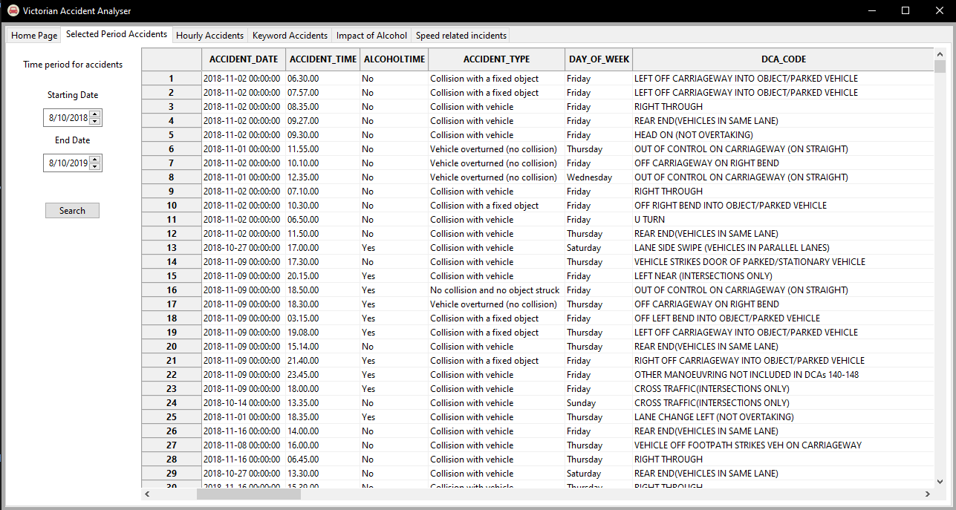These findings could be due to the fact that the busiest travels times are when heading to and from work and the likely hood of an accident is much greater. Highlighting that road safety during these peak times is a important piece of information to note.

*Figure 1: Selected Period Accidents Page*

# **Analysis 2 - Hourly Accidents**

Utilizing the VAA tool, the dataset analysed the distribution of accidents during the 12-month period, 8/10/2018 to 8/10/2019. The tool presented a bar graph detailing when the most accidents occurred per each hour.

Findings:

* The peak times were from 3pm to 6pm, during this time most schools finish and 9-5 workers finish causing what is called peak hour traffic.
* During 1am to 5am the least number of accidents occurred.

The reason for many of the accidents occurring between 3-6pm is due to the fact roads become extremely congested and drivers having difficulty moving between lanes. This results in accidents to occur more often.

*Figure 2: Hourly Accidents Page*

# **Analysis 3 - Keyword Accidents**

The VAA tool allows the user to input specific information into the system. The keyword chosen was Animal during the date period 8/10/2018 to 8/10/2019. This filter allows for more specific analysis into the data.

Findings:

* Most accidents occurred during evening to nighttime periods.
* The speeds at which most drivers were travelling at was of speeds exceeding 80km/hr.
* Expanding further into the data the table presents that most accidents occurred in rural areas.

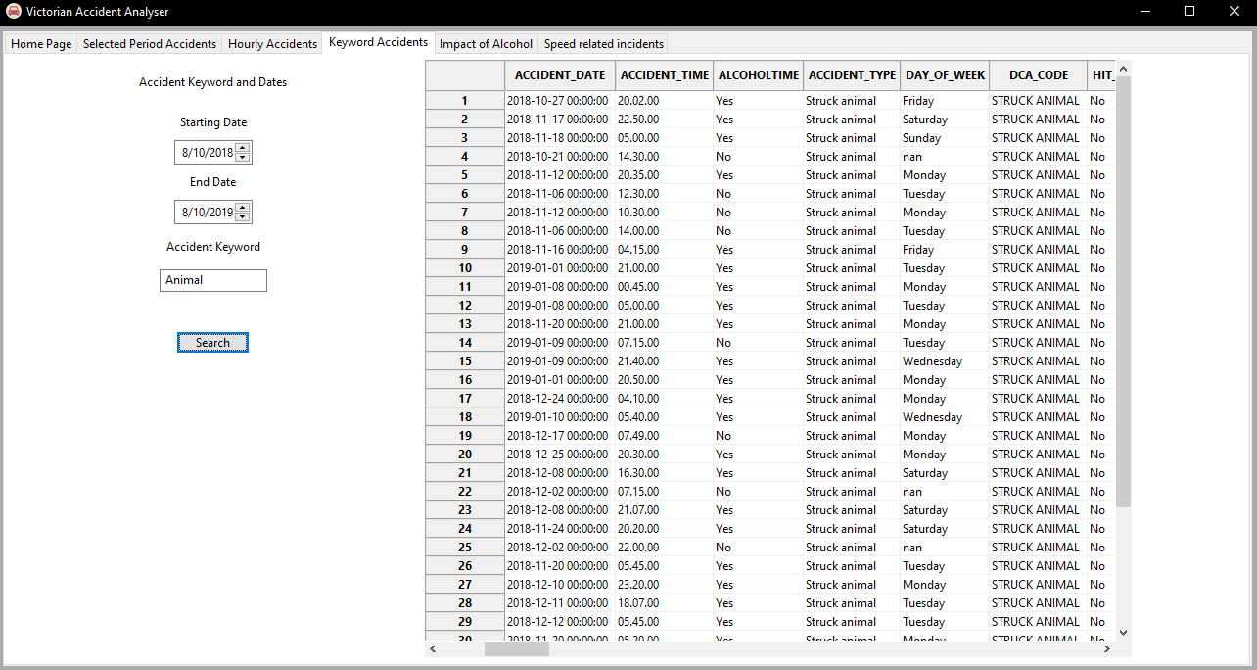The reason for these findings can be attributed to the increase in wildlife away from city suburban areas. Animals are more likely to be found in rural roads and highways, explaining why the accidents occur most of the time at speeds exceeding 80km/hr.

*Figure 3: Keyword Accidents Page*

# **Analysis 4 - Impact of Alcohol Accidents**

The Impact of Alcohol page uses similar features to the keywords page however users select from specific collision types from a drop-down menu. These being, struck pedestrian, collision with vehicle, collision with a fixed object, vehicle overturned (no collision), and struck animal. The users are also presented with the option to select whether Alcohol is involved, this being the primary purpose of the page.

Findings:

* Using the 12-month time period it was hard to get an accurate representation of when these alcohol related incidents occurred. In order to obtain better results the starting date and ending date were condensed down to a month period. This fixed the difficulty in reading the presented information.

Once the date period was condensed to a monthly viewing and once each month was selected during the same yearly period it was noted that most alcohol related accidents occurred during the Friday to Sunday period with a pedestrian being involved. This could be related to more restaurants and bars being open during the weekend period.

*Figure 4: Impact of Alcohol Page*

# **Analysis 5 - Speed Related Accidents**

The final page the Speed Related Accidents page presents two colour graphs effectively displaying how either day of the week effects the number of accidents at a given speed or how many injuries occurred at that given speed and their severity. Users only need to select the speed they wish to obtain information on and then are presented with the graphs.

Findings:

* It was found that all different speeds relate to different days of the week having accidents. An example being 40km/hr zones indicated that the majority of accidents occurred Monday to Friday, this implies that school zones may play an important role here.

*Figure 5: Speed Relating to Days of the Week Graph*

* Another key observation was that the most accidents occurred at 60km/hr due to that being the most widely used speed limit.
* The most fatalities occurred at 100km/hr showing that even though less accidents occurred during that period more fatalities happened when compared to 60km/hr which had nearly three times as many recorded incidents in total across all four injury categories.

This analysis suggests that speed although lower speeds presented less fatal/serious injuries more accidents occurred meaning that road conditions or even distractions play a large factor in this finding. *(Next page contains full page display)*

*Figure 6: Speed Related Accidents Page*